**Title:** Using tree-ring records to simultaneously characterize the influence of climate, tree size, and slowly changing environmental drivers on annual growth

**Authors:**

[Kristina J. Anderson-Teixeira1,2*](0000-0001-8461-9713), Valentine Herrmann1, Christy Rollinson3, Bianca Gonzalez1, Erika B. Gonzalez-Akre1, Neil Pederson4, Camille Piponiot1,2, Ross Alexander, Craig D. Allen, Raquel Alfaro-Sánchezwl, Tala Awada, Jennifer L. Baltzerwl, Patrick J. Baker, Sarayudh Bunyavejchewin, Paolo Cherubini, Justin Cooper, Stuart J. Davies2, Cameron Dow1, Ryan Helcoski1, [Jakub Kašparcz](0000-0003-1780-6310), James Lutz, Ellis Q. Margolis, Justin Maxwelljm, Sean McMahon2, Sabrina Russo, [Pavel Šamonilcz](0000-0002-7722-8797), Anastasia Sniderhanwl, Alan J. Tepley1,at, [Ivana Vašíčkovácz](0000-0002-6070-5956), Mart Vlam, Peter Zuidema

**Author Affiliations:**

1. Conservation Ecology Center; Smithsonian Conservation Biology Institute; Front Royal, VA 22630, USA
2. Center for Tropical Forest Science-Forest Global Earth Observatory; Smithsonian Tropical Research Institute; Panama, Republic of Panama
3. The Morton Arboretum, Lisle, Illinois, USA
4. Harvard Forest, Petersham, MA 01366, USA

wl. Biology Department, Wilfrid Laurier University, 75 University Ave W, Waterloo, ON, N2L 3C5

at. Canadian Forest Service, Northern Forestry Centre, Edmonton, Alberta, Canada

cz. Department of Forest Ecology, The Silva Tarouca Research Institute for Landscape and Ornamental Gardening, Lidická 25/27, 602 00 Brno, Czech Republic

jm. Department of Geography, Indiana University, Bloomington, Indiana, USA

*corresponding author: [teixeirak@si.edu](mailto:teixeirak@si.edu); +1 540 635 6546

**Running headline:** [45 chars]

# Abstract

*(needs to be re-written)*

1. Tree rings provide a valuable long-term record for understanding how climate shapes forest productivity. However, traditional analysis methods aggregate growth records of multiple trees into residual chronologies, and therefore cannot simultaneously account for the effects of climate, tree size, and slowly changing environmental drivers. This has limited the potential to use tree-rings to understand forest productivity, its climate sensitivity, and its global change responses.
2. Here, we develop a new method to simultaneously model non-linear effects of principle climate drivers and reconstructed tree diameter ($DBH$). Specifically, after identifying the most important climate drivers and theirtime window of influence, we use generalized least squares models to model growth while accounting for the temporal autocorrelation inherent to each individual tree’s growth. We apply this method to tree-ring data from 3797 trees representing 40 species at ten globally distributed sites spanning a wide range of forest types.
3. Our analysis identified similar climate drivers operating over similar time windows to those obtained via traditional methods, but revealed that non-linear responses to climate variables were common. Growth rates–expressed as ring widths, basal area increments, or biomass increments–varied non-linearly with $DBH$. The relative importance of $DBH$ versus climate varied across sites, and interactions between $DBH$ and climate were prevalent (*~50%* of cases tested). After accounting for $DBH$, growth rate varied directionally over time in most species– declining in most (90%).
4. Our method provides a rigorous analytical framework for statistically modeling tree growth responses to the most important climate drivers, $DBH$, and year in nonlinear models. The need for such an approach is highlighted by our findings that nonlinear growth responses to climate variables are common, that growth rates vary nonlinearly with $DBH$, that significant $DBH$- climate interactions are common, and that growth rates often change over time. By providing a framework for such analyses, our approach opens the door for using tree-rings to improve our understanding of forest responses to climate change.

**Keywords**: climate sensitivity; diameter; environmental change; Forest Global Earth Observatory (ForestGEO); generalized least squares (GLS); nonlinear; tree-ring

# Introduction

**Tree rings provide a long-term record of annual growth increments that is invaluable for understanding forests in an era of global change (Amoroso et al., 2017; Fritts & Swetnam, 1989).** Spanning time scales of decades to centuries or even millennia, they provide by far the most robust method for characterization of the interannual climate sensitivity of tree growth (Bräker, 2002; Fritts, 1976) and how it is changing (e.g., Sniderhan & Baltzer, 2016; Maxwell et al., 2016). Combined with forest censuses, they can be used to estimate forest woody productivity ($ANPP_{woody}$; Graumlich et al., 1989; Teets, Fraver, Hollinger, et al., 2018) and its climate sensitivity (Helcoski et al., 2019; Klesse et al., 2018; Teets, Fraver, Weiskittel, et al., 2018). *other global change drivers* This information is critical to predicting forest responses to climate change, and thereby reducing the enormous uncertainty surrounding future contributions of Earth’s forests to the global carbon cycle (Friedlingstein et al., 2006). Yet, collection and analysis of dendrochronological records has been traditionally been optimized to detect climate signals rather than to predict forest productivity, its climate sensitivity, and how it may be changing (Cherubini et al., 1998; Klesse et al., 2018; Nehrbass-Ahles et al., 2014). As a result, prevailing approaches hold a number of limitations for using tree-rings to address pressing questions concerning forest productivity in the current era of rapid environmental change.

**Dendrochronological methods to characterize the climate sensitivity of tree growth have been optimized to obtain the strongest possible climate signal for climate reconstructions, but face limitations when it comes to characterizing the climate sensitivity of individual trees or $ANPP_{woody}$.** Traditional methods begin by fitting a function (commonly a spline) to the growth record captured by each core, extracting residuals around the long-term trends, and then standardizing and averaging the residuals across cores to form a species-level ring-width index chronology (Fritts, 1976; Speer, 2010). Climate signals are then identified by examining month-by-month or seasonal correlations of the ring-width index chronology to one or more climate variables over the current year and, typically, previous year (e.g., Fritts, 1976; Meko et al., 2011; Zang & Biondi, 2015). Following identification of the top climate driver(s), statistical models describing their relationships to tree growth can be used for applications such as climate reconstruction (*DENDRO_REFS*) or projection of tree growth responses to climate change (e.g., Charney et al., 2016). An important caveat for the latter, however, is that the slopes of correlations between climate variables and ring-width index chronologies are not identical to the mean sensitivity of individuals within the population, as the process of building species chronologies fundamentally alters and obfuscates individual-level responses (*REF-NEIL?*). Although population-level climate responses have been approximated based on climate sensitives derived from species chronologies (e.g., Charney et al., 2016; Helcoski et al., 2019), the removal of individual-level variation prior to analysis of climate sensitivity limits potential for using species chronologies to characterize the climate sensitivity of $ANPP_{woody}$. In particular, analysis of species-level chronologies does not allow characterization of known variation in climate sensitivity in relation to tree size (discussed below), canopy position, or microhabitat (e.g., Bennett et al., 2015; McGregor et al., 2020; Rollinson et al., n.d.).

**Dendrochronological studies most commonly focus on linear climate responses to single climate drivers and the settings in which these occur, thereby missing nonlinearities and additive or interactive climate effects known to be widespread within forest settings.** Nonlinearities in climate sensitivities of tree metabolism and growth have been observed across a wide range spatio-temporal scales. Over time frames of seconds to days, photosynthesis and respiration display a unimodal relationships to temporal variation in temperature (REFS), typically peaking at temperatures *reflective of the environment to which the organism is acclimated (Kumarathunge et al., 2019)*. Across broad geographical climate gradients, annual forest productivity generally increases with temperature, precipitation, and potential evapotranspiration ($PET$) up to a point, after which it plateaus or decreases (Banbury Morgan et al., n.d.; Sullivan et al., 2020). Filling a critical gap between short-term physiological responses and the global gradients representing millennia of community assembly and species adaptation, the annual growth records of tree-rings capture tree growth responses to interannual climatic variation. Yet, because non-linearities are very problematic for reconstructing climate variables (Esper & Frank, 2009), systems exhibiting these are typically avoided–e.g., by sampling climate-limited forest boundaries, and analysis methods are designed around first-order linear growth-climate relationships (Fritts, 1976 **??**). Dendrochronological studies allowing for nonlinear or threshold responses of tree growth to climate are less common (Cavin & Jump, 2017; Cook & Johnson, 1989; Tolwinski-Ward et al., 2013; Tumajer et al., 2017; Woodhouse, 1999), and we therefore know little about the nonlinearities in growth responses to interannual variation in climate that occur for trees within forest settings. Furthermore, tree-ring studies do not commonly consider the additive or interactive effects of climate variables on annual growth (but see Meko et al., 2011; Foster et al., 2016; Sánchez-Salguero et al., 2015). Temperature and moisture are known to jointly shape tree growth (Beedlow et al., 2013; Foster et al., 2016) and forest productivity (e.g., Alexander et al., 2018; Banbury Morgan et al., n.d.), but their influence may occur over different time windows.

**Tree diameter at breast height ($DBH$) is closely correlated with numerous variables affecting tree growth rate [e.g., height, crown size and position, root mass; REF] and therefore is one of the most important variables influencing growth (e.g., Muller-Landau et al., 2006; Foster et al., 2016) and its climate sensitivity (e.g., Bennett et al., 2015; McGregor et al., 2020).** However, for dendrochronological studies aimed at deciphering climate signals, $DBH$ is not typically a variable of interest, and its influence is removed through detrending (Cook & Peters, 1997). Moreover, many studies constrain sampling to only larger size classes. While convenient for identifying climate signals (Fritts, 1976 ?), this approach is not optimal for subsequent inference of the climate sensitivity of forest productivity. Although climate correlations can be transformed to climate sensitivity (*i.e.*, magnitude of response, *sensu* Charney et al., 2016) and scaled to characterize the climate sensitivity of $ANPP_{woody}$ based on the scaling of $RW$ with $DBH$ (Helcoski et al., 2019), they cannot be used to characterize known interactive effects of $DBH$ and climate on tree growth. For example, larger trees tend to be relatively more sensitive to drought (Bennett et al., 2015; Gillerot et al., 2020; McGregor et al., 2020), and responses to temperature can also vary with tree size (Rollinson et al., n.d.; Rossi et al., 2007). However, the removal of $DBH$ signals via detrending makes it impossible to account for such size differences in climate sensitivity in a systematic, integrative way. To use tree-rings to predict tree growth, $ANPP_{woody}$, and forest dynamics, we need models that include $DBH$ (e.g., Evans et al., 2017; Klesse et al., 2020) and its potential climate interactions (e.g., Rollinson et al., n.d.).

**Characterizing how tree growth and forest productivity are responding to global change (slowly-changing environmental drivers) is very challenging and uncertain.** Directional climate change (as opposed to interannual variation), rising atmospheric carbon dioxide (CO2), and atmospheric deposition of sulfur dioxide (SO2) and nitrogen oxides (NOx) are all potentially influencing tree growth (**REFS**; Mathias & Thomas, 2018; Walker et al., 2020). At the same time, stand dynamics influence growth: tree growth rates are sensitive to competition (**REFS**), the intensity of which tends to increase as forests mature, and to canopy position, which can change directionally as trees overtop or are overtopped by their neighbors. Moreover, carbon allocation to woody growth – as opposed to leaf or root production, reproduction, defenses, etc. – is known to decline as individual trees and forest stands stands age (**REFS**; Thomas, 2011). However, tree size and time are almost inextricably linked (because each individual core increases in $DBH$ through time) and therefore difficult to disentangle, being subject to various sampling and analysis biases (Brienen et al., 2017, 2012; Cherubini et al., 1998; Hember et al., 2019; Nehrbass-Ahles et al., 2014; Peters et al., 2015; Sullivan et al., 2016).  
~~A variety of methods have been used to analyze directional changes in growth rate through time, including conservative detrending, where a mathematical function (e.g., negative exponential or stiff spline) is fit to growth trends in each individual core and residuals analyzed for trends and basal area correction, which assumes that the growth in a tree’s basal area ($BAI$) is fundamentally independent of size (Peters et al., 2015). A more reliable alternative is regional curve standardization, which uses an average age or size curve to describe ontogeny (~~*~~Esper et al. 2003~~*~~) and can be used in the context of multiple regressions or mixed-effects models [~~*~~REFS in Hember et al. (2019)~~*~~].~~ Continued improvement of analytical methods, in combination with sampling approaches that minimize potential biases, will be important to disentangling $DBH$ from time and detecting directional growth trends.

**Here, we develop a new method that allows simultaneous consideration of the effects of principle climate drivers (pre-selected in an objective manner), tree size and year on annual tree growth.** This approach allows us to ask: (1) What are the most important climate drivers (and their time windows), and what is the shape of the relationship between annual growth and these drivers? (2) How do $RW$, $BAI$, and aboveground biomass increments ($ΔAGB$) vary with $DBH$? (3) How do climate drivers and $DBH$ additively and interactively shape growth? (4) How have growth rates changed through time?

# Materials and Methods

## Data sources and preparation

We analyzed previously collected tree-ring data from ten sites ranging from 9.15 $​^{∘}$ to 61.30 $​^{∘}$ N latitude and representing a wide range of forest and tree types: tropical broadleaf deciduous and evergreen, temperate broadleaf deciduous and needleleaf evergreen, and boreal needleleaf evergreen (Tables 1, S1, S2). Nine of these sites (exception: LT) are large forest dynamics plots of the Forest Global Earth Observatory (ForestGEO; Anderson-Teixeira, Davies, et al., 2015; Davies et al., 2021). Trees of species represented within the ForestGEO plots were cored within the plot (n=#) and/or within 10 km (n=#), following a variety of sampling protocols designed to meet the varied objectives of the original studies (Tables S1, S3). In using this diversity of data sources, we ensured that our approach was able to handle challenges presented by varying methodologies and forest types.

**Table 1 | Sites included in this analysis**. Here and throughout, sites are ordered by descending mean annual temperature. Additional site information is provided in Table S1, and species and their sample sizes are detailed in Tables S2-S3. 

All tree cores were cross-dated and measured by the original researchers using standard dendrochronological practices. From among the full set of $RW$ measurements from *#* original cores, we excluded cores for which we detected errors (e.g., labeling inconsistencies, obvious dating errors) that could not be resolved before finalizing the analysis (n=*#*). We also excluded records that had to be excluded due to insufficient sample size or anomalous growth patterns, including (1) species with <7 cores, (2) cores with <30 years of record, (3) contiguous portions of cores containing large outliers ( $RW$ > mean plus 5 x SD of $RW$ for the entire core), and (4) the final 20 years prior to death of trees cored dead. The final criteria was implemented to avoid periods of growth decline and potentially altered climate sensitivity prior to death (Cailleret et al., 2017; DeSoto et al., 2020). From analyses including $DBH$ (see below), we further excluded (1) trees for which we lacked data required to reconstruct $DBH$, (2) trees for which there was a significant inconsistency between measured $DBH$ and the sum of $RW$’s across the core (Appendix S2), and (3) poorly represented edges of the $DBH$ range, starting where reconstructed $DBH$ (see below) was represented by <3 conspecific trees. In total, this resulted in inclusion of *#* cores, 4459 of which could be included in analyses with $DBH$ (Table S3).

For each year in the tree-ring records, we reconstructed $DBH$, as detailed in Appendix S2. We used allometric equations between $DBH$ and bark thickness to account for changes in bark thickness as the tree grew (Appendix S2; Tables S2, S4).

Once $DBH$ had been reconstructed, we used biomass allometries to estimate the corresponding aboveground biomass and diameter to area equation to get the corresponding basal area. We then calculated aboveground biomass growth increments ($ΔAGB$) as [$AGB_{y+1}−AGB_{y}$] and basal area increment ($BAI$) as [$BAI_{y+1}−BAI_{y}$]. Biomass allometries for temperate and tropical species were calculated using the R packages *allo-db* (Gonzalez-Akre et al. in review) and *biomass* (Réjou-Méchain et al., 2017), respectively.

Monthly climate data for 1901-2019 were obtained from CRU v.4.04 (Harris et al., 2014, 2020), and in a few cases corrected based on more local records (Appendix S3). Variables considered here included average daily minimum, maximum, and mean temperatures ($T_{min}$, $T_{max}$, $T_{mean}$, respectively); precipitation ($PPT$); and, when deemed reliable (Appendix S3), potential evapotranspiration ($PET$) and precipitation day frequency ($PDF$). All ForestGEO climate records used here are archived in the ForestGEO Climate Data Portal, v1.0 (Anderson-Teixeira et al., 2020).

## Analysis methods

Our analysis consisted of two main steps: (1) identification of the most important climate drivers and the time window over which they operate, and (2) combining $DBH$ and climate drivers into a multivariate model (Fig. 1). The analysis was run separately for each site (step 1), site-species combination (step 2), and each response variable ($RW$, $BAI$, or $ΔAGB$). We note that step 1 could be performed separately for each site-species combination, but for purposes of this analysis we sought to identify site-level climate drivers.



**Figure 1 | DRAFT Schematic illustrating our analysis process.** This analysis was conducted separately for each site (step 1) and species (step 2).

### Climate variable selection

We used the *climwin* package in R (van de Pol et al., 2016) to identify the most important climate driver and the time window over which its effect was strongest for each of two categories of variables: a temperature group ($T_{min}$, $T_{max}$, $T_{mean}$, and $PET$) and a precipitation group ($PPT$, $PDF$). To remove low-frequency variation that most likely represents responses to non-climatic drivers (*e.g.*, growth and aging of the tree, change in competitive dynamics, atmospheric pollution), we detrended the response variables by using a generalized additive model (GAM) to fit a spline to individual growth records ($RW$, $BAI$, or $ΔAGB$) from each core, thereby producing residuals. (*From coauthors: Include formula. How did you decide how flexible to make the spline?*) We then used *climwin* to identify the climate variables most strongly correlated to the residuals of $RW$, $BAI$, or $ΔAGB$, specifying quadratic fits to allow for potential nonlinearities in the climate response. Within *climwin*, we specified a mixed effects model using species (when $n≥3$) and core identity as random effects (noting that these effects should be minimal given that residuals are centered around zero): residual growth index ~ [climate] + (1 | sp) + (1 | treeID). Here, for each permutation, climate specifies one of the climate drivers in the climate variable group, analyzed over one of all possible combinations of consecutive months over a 15 month period ending near the time of cessation of formation of each annual ring (Table S1). *Climwin* runs all potential models to select the best fit (lowest AIC), and does k-fold cross-validation in its computation of AIC to guard against over-fitting (van de Pol et al., 2016). For each group of candidate climate variables, we moved forward with the best variable over the time window identified by *climwin* as a candidate climate variable for the multivariate models.

We tested whether this process identified similar climate variable-month combinations as what would be identified using traditional methods for individual species, as detailed in Appendix S4. Furthermore, we explored alternate methods of climate variable selection for the two sites that have undergone the most rapid changes in climate and tree growth: SC, where rapidly rising temperatures are causing melting permafrost, summer moisture stress, and growth declines (Sniderhan & Baltzer, 2016), and LT, where increasingly warm drought has dramatically reduced growth (**???**). We ultimately determined that the method described above was adequate for the purposes of this analysis (Appendix S5).

### Combining drivers in GLS model

Having identified candidate climate drivers in temperature and precipitation variable groups, we next combined climate variables (all models) and $DBH$ (models with $DBH$ and its climate interactions) in a generalized least squares (GLS) model (Fig. 1). Before running the models, we checked for collinearity among the candidate variables using the *vifstep* function (**REF**) and removed any variable with a variance inflation factor > 3 (none required removal). Within the GLS models, our response variables were $log[Δr]$, $log[BAI]$, or $log[ΔAGB]$. Rather than detrending these variables to produce residuals, the temporal autocorrelation of individual tree’s growth was accounted for by the specifying an autocorrelation structure of order 1, with $year$ as a continuous time covariate and $coreID$ as a grouping factor, in the GLS’s model specification. *(include model formula)* For each species independently, we ran every combination of the candidate climate variables and $DBH$, including both first- and second-order terms of polynomial for each. For climate responses, we allowed concave-down fits, but ignored any concave-up fits on the basis that these are not expected biologically and, when identified in initial analyses, often appeared to be cases of over-fitting.

For models including interactive effects of climate and $DBH$, we tested for interactions between first-order linear terms for climate variables and $DBH$.

To test for $year$ effects, we limited the analysis to species with reasonable coverage of an $DBH$ x year matrix. Specifically, we required that the species be represented by cores from $≥$ 3 trees spanning $≥$ 40% the total $DBH$ range for $≥2/3$ of the total time range analyzed. Species that failed to meet this criteria (n= **N**) were excluded from this analysis. We then ran models as described above, including a first-order linear effect of $year$. To verify that GLS model trends for $year$ were real, as opposed to an artifact of inherent covariation between $DBH$ and $year$ within each core, we compared GLS results to an analysis of $DBH$-growth relationships by decade (Figs. S32-S41). For simplicity and consistency with previous literature, we present only the models with $BAI$ as the growth metric, noting that responses were similar across metrics.

Within each of three categories of models run (climate only, climate + $DBH$, climate $×DBH$, climate + $DBH$ + $year$), we selected as the top model that with the lowest AIC.

# Results

## Climate sensitivity

Using $RW$ as the growth metric, our process identified similar climate drivers to those identified via traditional dendrochronological analysis methods (Figs. 2, S1-S4; Table S5; Appendix S4). While one-to-one correspondence of estimated climate coefficients was neither expected nor observed, estimates were correlated and rarely differed significantly (Appendix S4; S1-S4).

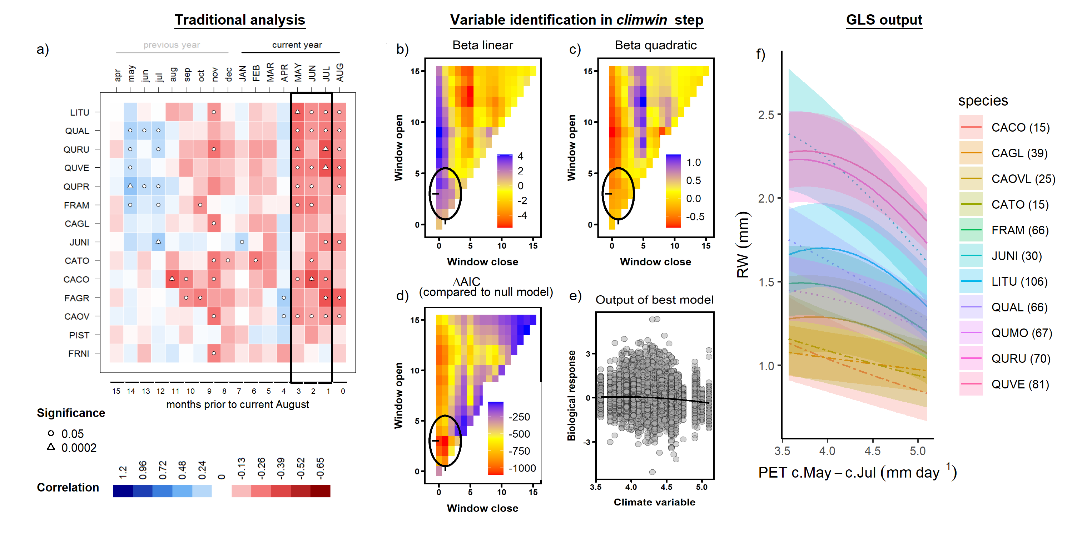

**Figure 2 | Example comparison of climate sensitivity derived via traditional methods (**a**) and our approach (**b-f**).** Example is for the sensitivity of 14 species at SCBI (codes given in Table S2) to potential evapotranspiration ($PET$). Panel (**a**) shows a matrix of Pearson correlations between ring-width index and monthly climate variables (using the chronologies of Helcoski et al. 2019). Black rectangle represents the period selected by *climwin* as the most influential window. Panels (**b-d**) give statistics for time windows tested in *climwin*, where window open and close indicate months prior to current August, and cells across the lower diaganol indicate single-month tests (akin to panel **a**). Panels (**b**) and (**c**) give values of linear and quadratic terms for each time window, and (**d**) gives the $ΔAIC$ for each. The time window with the minimum $ΔAIC$ (1-3 months prior to August, or May-July; black circles), was identified as the optimal window. Panel (**e**) shows the correlation of individual-level residuals to PET, with the function fit in *climwin*. Finally, panel (**f**) shows GLS model output, where $PET$ was a candidate driver variable (along with $PPT$; $DBH$ not included in this model). Plotted are responses of species for which $PET$ was included in the top model, with best-fit polynomials plotted with solid lines when both first- and second-order terms are significant, dashed lines when only one term is significant, and dotted lines when neither is significant. Transparent ribbons indicate 95% confidence intervals.

The three metrics of growth ($RW$, $BAI$, and $ΔAGB$) exhibited similar strength of correlation and direction of response to climate variables across the range of potential time windows, but the optimal time window or even the top climate variable sometimes differed (Figs. S5-S7). In 8 of 20 cases, both the optimal climate variable and time window were identical across growth metrics (e.g., Fig. S5). In 10 cases, *climwin* identified the same climate variable but different (often overlapping) time windows (e.g., Fig. S6). Finally, in two cases of variables that had only weak effects and mixed responses among species in the final models (temperature variable group at HKK, precipitation variable group at HF; Figs. 3, S11, S17), *climwin* identified different climate variables and different time windows (e.g., Fig. S8). Henceforth, unless otherwise noted, we focus on the climate sensitivities identified with $RW$ as the growth metric and for the full set of cores (*i.e.*, including those for which $DBH$ could not be reconstructed).

Within the context of the GLS model, which tested for first- and negative second- order linear effects of both a precipitation and a temperature variable, both a precipitation and a temperature variable were included in the top model for 80% of site-species combinations (n=37 of 46; Fig. 3). There were seven site-species combinations for which only a precipitation term was significant (2 at BCNM, 3 at SCBI, and 2 at LDW), one for which only a temperature term was significant (*Chukrasia tabularis* at HKK), and none with no significant climate responses. Precipitation and temperature variables were rarely influential over the same time window (exception: LDW). Below, we summarize the precipitation and temperature variables included in these models and their direction of response.

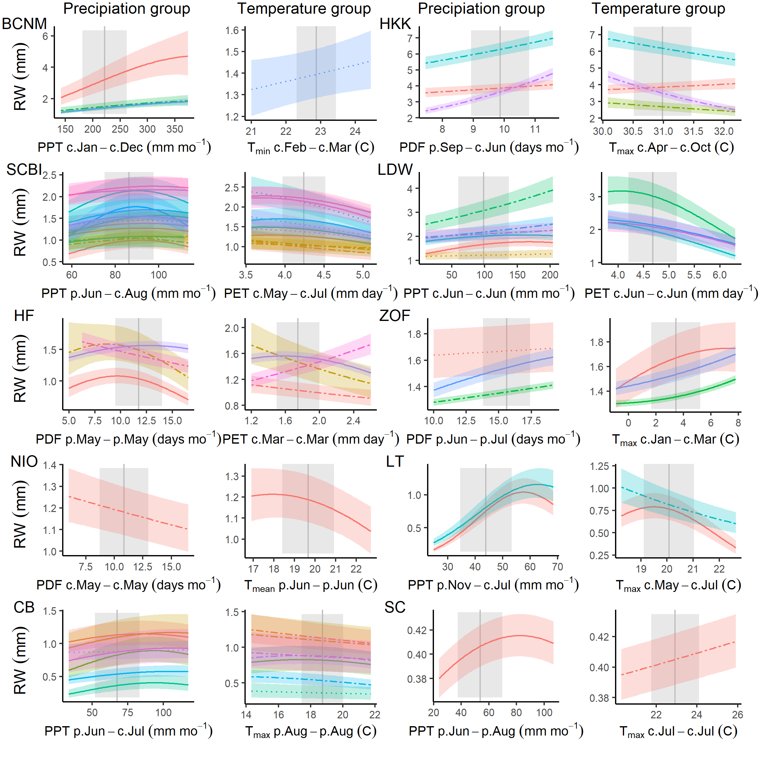

**Figure 3 | Species-level responses of $RW$ to climwin-selected variables in precipitation and temperature variable groups.** *Climwin*-selected climate variables are coded on the x-axes as the climate variable name followed by the range of months (p=previous year, c=current year) over which it is most influential. For each species (color-coded as in Fig. 4), relationships are plotted if included in top model. For each relationship shown, other terms in the model are held constant at their median. Best-fit polynomials are plotted with solid lines when both first- and second-order terms are significant (t-test’s p-value <0.05), dashed lines when only one term is significant, and dotted lines when neither is significant. Transparent ribbons indicate 95% confidence intervals. Vertical grey lines indicate the long-term mean for the climate variable, shading indicates 1 SD.

Responses to precipitation amount ($PPT$) and frequency ($PDF$) were included in the best model for all but one species, and were predominantly positive (Fig. 3). $PPT$ and $PDF$ were each identified as the top variable in four of the eight sites with both variables available, while $PPT$ was the only option at two (LT and CB). Optimal time windows most commonly coincided at least partially with the months of most active growth in the current year (Fig. 3; Table S1): wet seasons in the tropics (BCNM and HKK) or late spring/ early summer in the extratropics (n= 5 of 8). In the tropics, the long time windows over which precipitation was influential (12 mo at BCNM, 9 mo at HKK) also included the majority (BCNM) or all (HKK) of the dry season. At two extratropical sites (LDW, NIO), the most influential windows were limited to the current spring and early summer, whereas optimal windows at three sites extended back to the previous fall (LT, CB) or summer (SCBI). Finally, at three sites (HF, ZOF, and SC), precipitation of the previous growing season was the most influential variable. Responses to $PPT$ or $PDF$ were predominantly positive, with positive first-order linear terms for all but two species (*Tsuga canadensis* at HF and *Betula papyrifera* at NIO; Fig. 3). Negative second-order terms were commonly included in the best model (32 of 42 with positive first-order terms), generally resulting in a deceleration or decline at the highest levels of precipitation, but occasionally producing a unimodal (e.g., several species at SCBI) or predominantly negative response (e.g., BEAL at HF; Fig. 3). At the riparian site (NIO), for which streamflow was included as a candidate variable in the precipitation group, May $PDF$ was selected as the strongest driver but had a modest negative effect on growth, indicating that water availability was not a significant limitation for *Betula papyrifera* at this site.

A temperature variable was included in the best model for all but eight site-species combinations, with predominantly negative responses, particularly at the higher end of the temperature range (84%; 34% with negative first-order term, 50% with positive first-order term but negative second-order term; Fig. 3). The most commonly selected variables within the temperature group were $T_{max}$ and $PET$, which were identified by *climwin* as the top temperature-related driver at five and three of the ten sites, respectively, noting that $PET$ was not available for two sites. $T_{mean}$ and $T_{min}$ were each identified as the top driver at only one site (NIO and BCNM, respectively), noting that the effects of $T_{min}$ at BCNM were only marginally significant (Fig. 3). Optimal time windows most commonly occurred during the peak growing season of the current year (n= 5 of 10 sites), but there were cases where optimal windows occurred during the preceding dry season (BCNM), late winter/early spring (HF, ZOF), or the previous growing season (NIO, CB). Within the tropics, there was minimal effect of temperature at BCNM and a negative effect of wet season $T_{max}$ for three of four species at HKK. For temperate sites with optimal time windows covering the current and/or past growing season, responses were universally negative (*i.e.*, negative first-order linear or unimodal, peaking at temperatures lower than the long-term mean). In contrast, there were positive effects of Jan-March $T_{max}$ for all three species at ZOF and of March $PET$ for *Tsuga Canadensis* at HF, the latter contrasting with a negative response of the other three species at HF (Fig. 3). At the highest-latitude site (SC), which has undergone rapid warming and permafrost melt, *Picea mariana* responded positively (but with wide 95% CI on the slope) to temperature over the full analysis period (1903-2013); however, responses were predominately positive prior to 1970 and predominantly negative afterwards (Fig. S29).

## Influence of DBH

**All three growth metrics, $RW$, $BAI$, and $ΔAGB$, varied with $DBH$ for most species at all sites (Fig. 4). $RW$** varied significantly with $DBH$ for 81% of species-site combinations (n= 35 of 43), and the majority of best models included a significant second-order linear $DBH$ term (n= 26, 21 of which were negative). There was substantial variation in these trends, with patterns mixed across both forests and species within a single stand (Fig. 4). On one end of the spectrum, some species exhibited maximum $RW$ at low $DBH$, followed by fairly rapid declines in $RW$ with increasing $DBH$. Species following this pattern either had low to at most intermediate shade tolerance (e.g., *Melia azedarach* at HKK, *Juglans nigra* at SCBI, *Acer rubrum* at HF, *Betula papyrifera* at NIO; *Populous tremuloides* at CB; Table S2) and/or grew in relatively open stands (e.g., both species at LT, *Picea mariana* at SC; Fig. 4). At the other end of the spectrum, some species had low $RW$ at small $DBH$, increased to peak $RW$ at intermediate $DBH$, and subsequently declined. These included, but were not limited to, shade-tolerant species at sites where they presumably established under closed-canopy conditions (e.g., *Trichilia tuberculata* and *Tetragastris panamensis* at BCNM; *Fagus* spp. at SCBI and Žofín, *Acer saccharum* at LDW, *Picea* spp. at Žofín and CB; Table S2).

**Trends in both $BAI$ and $ΔAGB$ were far more consistent across sites and species, most commonly increasing to a peak at intermediate $DBH$ and then declining (Fig. 4).** Best models for $BAI$ included $DBH$ and $DBH^{2}$ for 42 of 43 species (exception: *Acer rubrum* at HF), with a positive coefficient for $DBH$ in 40 (exceptions: non-significant negative coefficients for *Pinus ponderosa* at LT and *Pinus longaeva* at CB, whose reconstructed $DBH$ s did not extend down to 0cm within the time frame analyzed) and near-universally negative coefficients for $DBH^{2}$ (exception: *Pinus longaeva* at CB). For $ΔAGB$, models were even more consistent, with the best models for 98% of species containing a positive coefficient for $DBH$ and a negative coefficient for $DBH^{2}$ (exception: *Pinus longaeva* at CB).

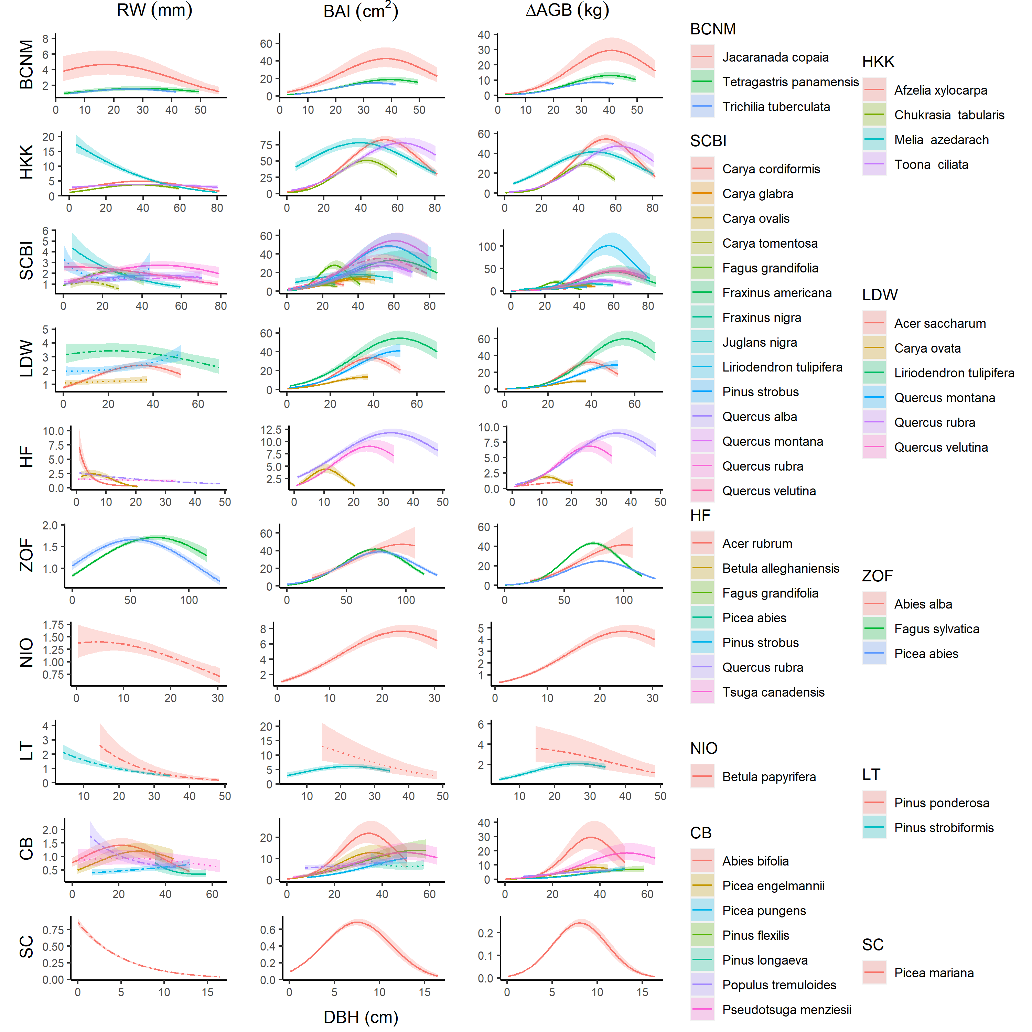

**Figure 4 | Growth sensitivity to DBH: (a) $RW$, (b) $BAI$, (c) $ΔAGB$.** Relationships for species are plotted when included in the top model. Other terms in the model are held constant at their median. Best-fit polynomials are plotted with solid lines when both first- and second-order terms are significant (t-test’s p-value <0.05), dashed lines when only one term is significant, and dotted lines when neither is significant. Transparent ribbons indicate 95% confidence intervals.

## Additive and interactive effects of climate and DBH

When a precipitation variable, a temperature variable, and $DBH$ were all included as candidate variables in the GLS models, typically all three were included in the top model, regardless of the growth metric used. Climate responses were generally similar to those described above for models without a $DBH$ term, although some of the weaker climate responses were not consistently included in top models (e.g., $T_{min}$ responses at BCNM; Figs. 3, S9-S28). Responses to $DBH$ were as described above (Fig. 4).

In general, $DBH$ explained more variation in growth rates than did climate, but its relative importance varied across growth metrics and sites (Figs. S9-S28). The relative importance of $DBH$ tended to be least for $RW$, intermediate for $BAI$, and highest for $ΔAGB$ (e.g., at SCBI; Fig. S13). However, there were exceptions, particularly when $RW$ decreased steeply with $DBH$ (e.g., LT; Fig. S23). The relative importance of climate was modest (but still significant) at sites including SCBI (Fig. S13), HF (Fig. S17), and SC (Fig. S27), and stronger at sites including BCNM (Fig. S9) and LT (Fig. S23).

Interactive effects of climate and $DBH$ were found for 88 of the 204 (43%) species-variable combinations for which they were tested. For precipitation variables, interactions were significant for 16 of the 36 (44%) interactions with $RW$ as the growth metric (Fig. S30) and for 17 of the 36 (47%) with $BAI$ as the growth metric (Fig. S31). The majority of these interactions were positive (75% for $RW$; 59% for $BAI$), indicating that larger trees generally respond more positively (or less negatively) to precipitation or its frequency (Fig. 5). Among the exceptions to this pattern (n=4 for $RW$, 7 for $BAI$), only a minority (n=1 for $RW$, 4 for $BAI$) occurred in species responding positively to precipitation in the current growing season.

Temperature variable $×DBH$ interactions were significant for 38% of cases with $RW$ as the growth metric (Fig. S30) and for 47% with $BAI$ as the growth metric (Fig. S31). Directions of these interactions were mixed, with 5 of 12 significant interactions negative with $RW$ as the growth metric and 9 of 15 significant interactions negative when $BAI$ was the growth metric. For both $RW$ and $BAI$, the majority of significant negative interactions (*i.e.*, more negative/ less positive response of larger trees to higher temperatures) occurred in the more water-limited forests (HKK, LT, CB), whereas positive interactions were more common in mesic forests (SCBI, HF, ZOF).



**Figure 5 | Examples of climate - DBH interactions for three species.** Shown are modeled response functions for minimum and maximum DBH…

## Effects of year

There was a significant effect of year in the GLS models for 30 - 32 (depending on growth metric) of the 37 species- site combinations tested (Figs. 6, S9-S28), and these trends were consistent with those observed in a separate analysis of $DBH$-growth relationships by year (Figs. S32-S41). In 90-91% of cases (depending on growth metric), the growth trend over time was negative. Declines were particularly dramatic for *Picea mariana* at SC, *Pinus ponderosa* at LT, all four species at HF, and several species at SCBI (Fig. 6). In these cases, models without year predicted declines in growth at large DBH that should more properly be attributed to the effect of year (Fig. 6). Significant positive growth trends were observed for only three species, *Fagus sylvatica* at ZOF, *Picea pungens* and *Pinus flexilis* at CB, and all were modest compared to the steep negative trends observed for some species. Growth rate was consistently independent of year for only four species: *Chukrasia tabularis* at HKK, *Pinus strobiformis* at LT, and *Picea engelmannii* and *Pinus longaeva* at CB.

Effects of year and $DBH$ interacted such that inclusion of year in in models altered the shape of $DBH$ responses, typically resulting in less pronounced growth declines with increasing $DBH$ (Figs. S9-S28).

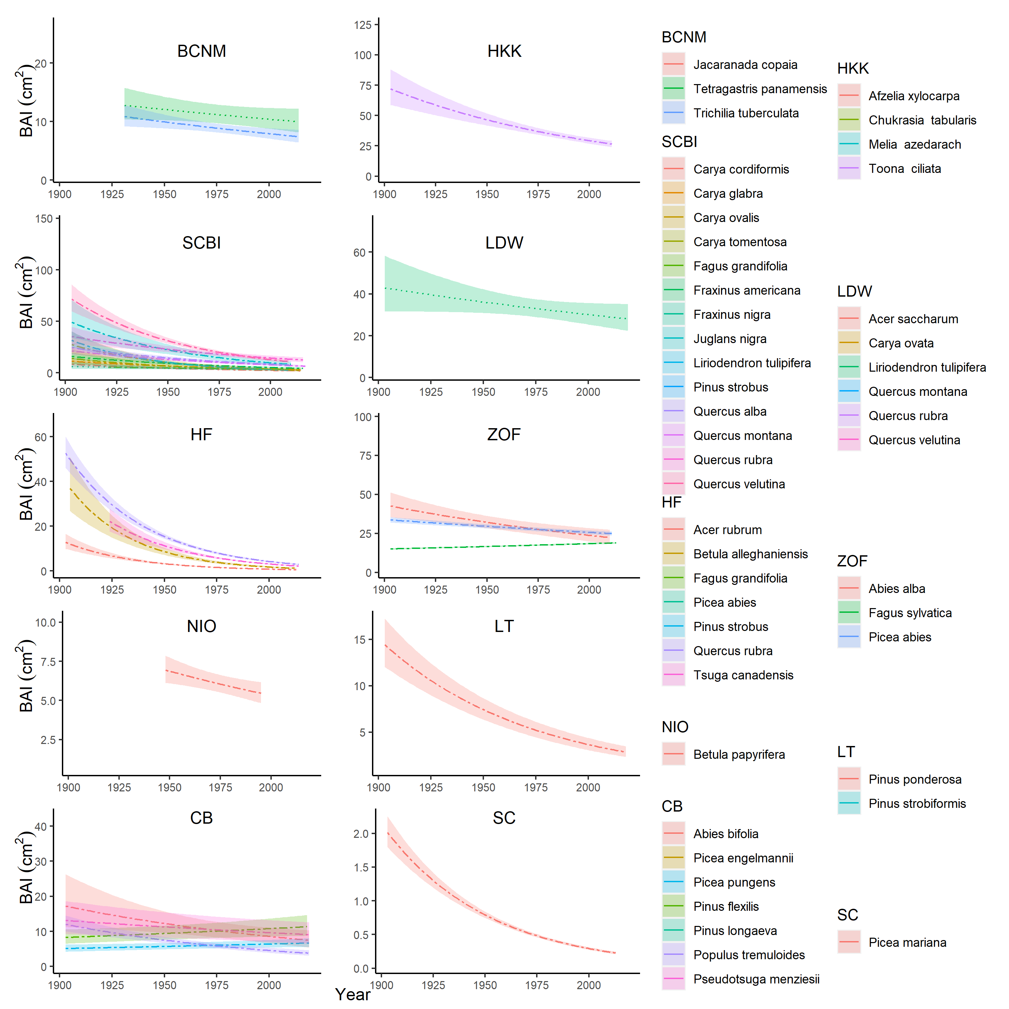

**Figure 6 | Effect of year, when included in the best model, on BAI.** For each species (color-coded as in Fig. 4), relationships are plotted if included in top model. Other terms in the model are held constant at their median. Best-fit polynomials are plotted with solid lines when both first- and second-order terms are significant (t-test’s p-value <0.05), dashed lines when only one term is significant, and dotted lines when neither is significant. Transparent ribbons indicate 95% confidence intervals.

# Discussion

Our new tree-ring analysis method allows simultaneous consideration of the effects of dominant climate drivers, tree size, and slowly changing environmental conditions on annual growth (Fig. 1), yielding results that are consistent with those that would be obtained using conventional methods (Figs. 2, S1-S4; Table S5) while offering a fuller picture of the drivers of tree growth in an era of global change. Below, we summarize how our results on the effects of climate, tree size, and year corroborate current understanding of the drivers of tree growth while yielding new insights made possible by the approach.

## Climate sensitivity

Across diverse climates and forest types (Tables 1, S2), growth rates of 40 tree species generally responded positively to water availability ( $PPT$ or $PDF$)–at least up until the long-term mean– and negatively to temperature (usually $T_{max}$ or $PET$), with the exception of several positive responses at times and in places where temperature was limiting (Fig. 3). *(Discuss how this fits with regional to global-scale studies)*

While our approach identifies similar climate sensitivities to those that would be identified using conventional methods (Figs. 2, S1-S4; Table S5), it differs in some substantive ways. First, in determining the most important climate drivers (step 1; Fig. 1), we consider the full sample of individual cores, as opposed to a residual chronology in which variance has been standardized and the individual cores have been averaged. Some differences in variables identified and the slope between growth and climate are to be expected giving the methodological differences (Appendix S4); however, as a whole the identified drivers and directions of response are consistent with conventional methods (2, S1-S4; Table S5). Another way in which the current analysis differed from conventional methods is that we pooled species by site when determining the top climate drivers (step 1; Fig. 1). This decision was motivated by the expectation that differences in optimal climate windows across species in one site would be minimal compared to cross-site differences (cf. Figs. 2, 3); however, analyses focused on interspecific differences could optimize species-specific climate sensitivity estimates by fitting *climwin* individually be species.

Another way in which our analysis differed fundamentally from most conventional approaches was in testing for non-linear responses of growth to climate, finding that nonlinear responses were *common/ prevalent*. *(DISCUSS)*

Finally, our analysis differed from conventional approaches in the use of GLS models to simultaneously quantify the effects of climate, $DBH$, and year, while accounting for idiosyncratic growth trends of individual trees through an autocorrelation structure (step 2; Fig. 1; see also Evans et al., 2017; Rollinson et al., n.d.). This approach allowed the consideration of additive and interactive effects of climate with variables that change over longer time frames–here, $DBH$ and year, although other slowly-changing drivers could also be used. We found that interactions between climate variables and $DBH$ were common (43%; Figs. 5, S30, S31). The most coherent pattern observed in this analysis was a tendency for larger trees to be more sensitive to precipitation and high temperatures (Fig. 5), consistent with widespread observations that larger trees are more sensitive to drought (REFS; Bennett et al., 2015; Gillerot et al., 2020; Hacket-Pain et al., 2016; McGregor et al., 2020; Pretzsch et al., 2018). An analytical structure that can account for this and other such DBH-climate interactions (e.g., Rossi et al., 2007; Rollinson et al., n.d.) will be critical to using tree-ring records to understand and forecast the effects of climate on tree growth and forest productivity. We note that a modification of our analysis method (modeling $year×$ climate interactions instead of $climate×$ climate interactions) could potentially be used to account for directional changes in climate sensitivity, which have commonly been observed (REFS- Maxwell, Helcoski; Peltier & Ogle, 2020; Zuidema et al., 2020).

## Variation with $DBH$

Growth rate–whether measured as $RW$, $BAI$, or $ΔAGB$– varied nonlinearly with $DBH$ for the vast majority of site-species combinations (81 - 98% depending on growth metric; Fig. 4). Variation in these patterns–particularly for $RW$, for which variation was most pronounced–was driven by two primary, interrelated factors: species ecology and stand history. Species that would have established in fairly open conditions–*i.e.*, shade-intolerant species (Table S2) and those at sites with more open canopies (e.g., LT, SC)– exhibited rapid initial growth, measured as $RW$, followed by a roughly exponential decline. Such patterns are consistent with dendrochronology’s “textbook” patterns, which have been derived primarily from trees that established in high-light environments (Biondi & Qeadan, 2008; Fritts, 1976). However, within the forest settings studied here, the majority of species exhibited initially low, but increasing, $RW$. This latter pattern is consistent with the observation that when contemporary growth rates are compared across individuals within a stand (*i.e.*, a “cross-sectional” analysis), $RW$ increases continuously with $DBH$ (e.g., Muller-Landau et al., 2006; Anderson-Teixeira, McGarvey, et al., 2015; Helcoski et al., 2019), or increases and subsequently decreases (Schelhaas et al., 2018).

We found evidence of saturation or decline in the majority (77%) of species-site combinations analyzed (Fig. 4), contrasting with findings of cross-sectional analyses showing that $ΔAGB$ increases continuously with $DBH$ (Meakem et al., 2018; Stephenson et al., 2014), which has also been observed in tree-rings (Foster et al., 2016). In large part, this discrepancy can be explained by differences between cross-sectional analyses and “longitudinal” patterns of individual trees through time (Forrester, 2021; Sheil et al., 2017). Declines in $BAI$ and $ΔAGB$ at larger $DBH$ are probably in part attributable to increasing allocation to reproduction (Thomas, 2011), and are also linked to slowly changing environmental conditions (e.g., successional changes in stand structure, climate change; discussed below). Notably, inclusion of year in the GLS models tended to reduce the magnitude of $BAI$ and $ΔAGB$ declines at larger $DBH$ (Figs. S9-S28), suggesting that some of such declines in Figure 4 are more properly attributed to the effect of year than that of $DBH$.

## Changing growth rates

Growth rates changed directionally for the majority (73-78%, depending on growth metric) of site-species combinations selected for analysis based on the sampling representation of $DBH$ by $year$ (Fig. 6). These results were similar across growth metrics (Figs. S9-S28), and consistent with an independent analysis of growth- $DBH$ trends by decade (Figs. 6, S32-S41), indicating that our approach is robust in its analytical structure. Indeed, in a comparative analysis of several methods commonly used to detect growth trends, approaches similar to that employed here (regional curve standardization) performed better at growth trend detection (Peters et al., 2015) than two of the most commonly used methods for analyzing growth trends, conservative detrending and basal area correction (see Peters et al., 2015), both of which would fail to capture the observed trends in $RW$ and $BAI$ with $DBH$ (Fig. 4). For instance, based on our finding that $BAI$ tends to rise and fall with $DBH$, basal area correction would generally be biased towards finding positive trends for smaller trees and negative trends for larger trees. However, are results remain subject to the influence of some potential sampling and survivorship biases that can influence overall trends in positive or negative directions (Fig. 6; Brienen et al., 2012, 2017; Nehrbass-Ahles et al., 2014). While we have made efforts to control for the most severe potential biases (see Methods), and while the statistical model applied here in theory accounts for persistent growth differences among trees through a random effect of tree, some potential biases are difficult, if not impossible, to control for (Brienen et al., 2017). The observed trends must therefore be interpreted with caution, and in light of the fact that growth trends inferred from tree rings can be strongly shaped by tree demography (Brienen et al., 2017).

*… corroborates previous analyses from HKK showing growth decreases over time (Groenendijk et al., 2015, but see @brienen_tree_2017; Nock et al., 2011; van der Sleen et al., 2015).*

*coauthors, I’d appreciate site-specific feedback on the two following paragraphs:*

To the extent that sampling and survivorship biases are minimal, signals of changing growth rate over time are attributable to some combination of stand dynamics (e.g., recruitment and succession, changing stand structure) and environmental drivers (e.g., climate drivers other than those selected by *climwin*; atmospheric CO2; deposition of sulfur dioxide, SO2, and nitrogen oxides, NOx). The majority of negative growth trends observed here are probably attributable to successional stand dynamics as cohorts and stands age. For species exhibiting a pulse of recruitment in the past and little subsequent recruitment (e.g., **SPECIES, FIGURES**), variation in growth rates among individuals would naturally lead to a trend of declining growth, as faster-growing individuals reach various size thresholds earlier (Brienen et al., 2017). Such a trend is not indicative of a directional response to changing environmental conditions that would be generalizable across stands (e.g., rising atmospheric CO2), but does indicate a decline of the species within the stand. This can occur, for example, when a light-demanding species is no longer recruiting under a closed canopy, which is the likely explanation for declines in several species (e.g., **SPECIES, FIGURES/TABLES**). In secondary stands, particularly those where the majority of trees established at a similar time (**SCBI, HF,…**; Appendix S1 **FIGURES**), growth declines are consistent with the tendency for faster tree growth during early succession (**REFS**), and with increasing competition as young stands mature (**REFS**). Even within mature forests, light-demanding species that establish in gaps (e.g., *Jacaranda copaia* at BCNM, *Populus tremuloides* at CB; Table S2) would tend to experience an increasingly competitive environment. For more shade-tolerant species in stands with no known disturbance within the past 1.5 centuries (**ZOF?, NM?, CB, SC**), trends would represent more gradual successional changes or responses to global change. At Cedar Breaks, which has tree-ring records dating back to 0 AD (Cooper & Lutz, unpublished data), mixed growth trends probably reflect later successional changes in a mixed-disturbance forest and/or shifting competitive advantages, perhaps in part driven by changing environmental conditions.

In a few instances, directional changes in growth are likely attributable to abiotic drivers. In the Czech Republic (ZOF), acid deposition dramatically reduced growth in *(DECADES)* [**REFS**], as captured in our records (Fig. S37), and *this influenced linear growth trends of different species in differently within the GLS model*. In cases such as this, a non-linear response function to $year$, or incorporation of data on pollution, would be needed to accurately characterize changing growth trends, but that is beyond the scope of the current anlaysis. In New Mexico (LT), *we suspect that a strong drying trend is not fully captured by the dominant climate drivers (?).* At Scotty Creek, rapid warming and melting permafrost are altering hydraulic conditions, resulting in growth declines, high mortality, and low recruitment of *Picea mariana* (Dearborn et al., 2020; Sniderhan & Baltzer, 2016).

There is a notable lack of evidence that growth rates of any species are are benefiting substantially from increasing CO2. With a few potential exceptions (*Fagus sylvatica* at ZOF, *Picea pungens* and *Pinus flexilis* at CB; Fig. 6), any growth benefit from elevated CO2 was generally outweighed by successional changes or chronic environmental shifts. A growth benefit of CO2 is potentially expected based on physiological mechanisms and has been observed in young forests in experimental settings (Walker et al., 2020); however, it does not appear to be substantial for the older trees in natural forest settings analyzed here. Indeed, significant woody growth stimulation by elevated CO2 has not been observed in experimentally manipulated mature forests (Walker et al., 2020), and previous tree-ring studies overall find little evidence of increasing tree growth rates (e.g., Hararuk et al., 2019; Walker et al., 2020).

## Conclusions

Altogether, our analysis method reveals a much richer picture of the factors influencing tree growth than has previously been possible. Specifically, it allows us to show that growth is generally simultaneously influenced by temperature and precipitation over different time windows, that nonlinear climate responses and interactive effects of climate with $DBH$ are common (Figs. 3 and 5, respectively), that growth–measured by any metric–almost universally varies with $DBH$ (Fig. 4), and that growth of most species has been declining in response to a changing environment (stand successional status or global change; Fig. 6). While traditional dendrochronology methods, particularly those focused on climate reconstruction, generally sample and analyze data in order to minimize many of these effects, they of great interest and significance from an ecological perspective. As global change pressures intensify and the need to understand changing forest dynamics becomes increasingly urgent (REFS) (McDowell et al., 2020), we expect that this approach will prove valuable to understanding drivers of tree growth and forest change.

# Acknowledgements

Thanks to Helene Muller-Landau and Pete Kerby-Miller for bark thickness data. Helpful feedback was provided by Helene Muller-Landau, Albert Kim… This analysis was funded by a Smithsonian Scholarly Studies grant to KAT, SM, HCM, and CP. The participation of PS, JK, and IV from the Czech Republic was supported by the Czech Science Foundation, project No. 19-09427S

# Authors’ contributions

KAT, VH, CR, RA, CP conceived the ideas and designed methodology; [most authors] collected the data; VH, BG, EGA, and NP organized and analysed the data; KAT led the writing of the manuscript. All authors contributed critically to the drafts and gave final approval for publication.

# Data availability

*To enable readers to locate archived data from papers, we require that authors list the database and the respective accession numbers or DOIs for all data from the manuscript that has been made publicly available.*

Code and full results are available via the project repository in GitHub (github.com/EcoClimLab/ForestGEO-climate-sensitivity) and archived in Zenodo (DOI: TBD) . Data for # of the sites are archived in the The DendroEcological Network (DEN) database (Rayback et al., 2020).

# Supplementary files

Appendix S2. Methods for reconstruction of $DBH$

Appendix S3. Methods for climate data evaluation and correction

Appendix S4. Methods for comparing our approach with traditional methods

Appendix S5. Dealing with rapidly changing climate and tree growth

Table S1. Site Details.

Table S2. Species analyzed, their characteristics, and bark allometries applied.

Table S3. Sampling details for species by site.

Table S4. Allometric equations for bark thickness.

Table S5. Qualtiative comparison of results from this study with previous studies employing conventional methods.

# References

Alexander, M. R., Pearl, J. K., Bishop, D. A., Cook, E. R., Anchukaitis, K. J., & Pederson, N. (2019). The potential to strengthen temperature reconstructions in ecoregions with limited tree line using a multispecies approach. *Quaternary Research*, *92*(2), 583–597. <https://doi.org/10.1017/qua.2019.33>

Alexander, M. R., Rollinson, C. R., Babst, F., Trouet, V., & Moore, D. J. P. (2018). Relative influences of multiple sources of uncertainty on cumulative and incremental tree-ring-derived aboveground biomass estimates. *Trees*, *32*(1), 265–276. <https://doi.org/10.1007/s00468-017-1629-0>

Alfaro-Sánchez, R., Muller-Landau, H. C., Wright, S. J., & Camarero, J. J. (2017). Growth and reproduction respond differently to climate in three Neotropical tree species. *Oecologia*. <https://doi.org/10.1007/s00442-017-3879-3>

Amoroso, M. M., Daniels, L., Baker, P. J., & Camarero, J. J. (Eds.). (2017). *Dendroecology: Tree-Ring Analyses Applied to Ecological Studies*. Springer International Publishing. <https://doi.org/10.1007/978-3-319-61669-8>

Anderson-Teixeira, K., Gonzalez, B., ForestGEO, McGregor, I., Gonzalez-Akre, E., RHelcoski, Herrmann, V., Kim, A. Y., Terrell, A., & Camerondow35. (2020). *Forestgeo/Climate: Initial release*. Zenodo. <https://doi.org/10.5281/ZENODO.3958215>

Anderson-Teixeira, K. J., Davies, S. J., Bennett, A. C., Gonzalez-Akre, E. B., Muller-Landau, H. C., Joseph Wright, S., Abu Salim, K., Almeyda Zambrano, A. M., Alonso, A., Baltzer, J. L., Basset, Y., Bourg, N. A., Broadbent, E. N., Brockelman, W. Y., Bunyavejchewin, S., Burslem, D. F. R. P., Butt, N., Cao, M., Cardenas, D., … Zimmerman, J. (2015). CTFS-ForestGEO : A worldwide network monitoring forests in an era of global change. *Global Change Biology*, *21*(2), 528–549. <https://doi.org/10.1111/gcb.12712>

Anderson-Teixeira, K. J., McGarvey, J. C., Muller-Landau, H. C., Park, J. Y., Gonzalez-Akre, E. B., Herrmann, V., Bennett, A. C., So, C. V., Bourg, N. A., Thompson, J. R., McMahon, S. M., & McShea, W. J. (2015). Size-related scaling of tree form and function in a mixed-age forest. *Functional Ecology*, *29*(12), 1587–1602. <https://doi.org/10.1111/1365-2435.12470>

Banbury Morgan, B., Herrmann, V., Kunert, N., Bond-Lamberty, B., Muller-Landau, H. C., & Anderson-Teixeira, K. J. (n.d.). Global patterns of forest autotrophic carbon fluxes. *Global Change Biology*.

Beedlow, P. A., Lee, E. H., Tingey, D. T., Waschmann, R. S., & Burdick, C. A. (2013). The importance of seasonal temperature and moisture patterns on growth of Douglas-fir in western Oregon, USA. *Agricultural and Forest Meteorology*, *169*, 174–185. <https://doi.org/10.1016/j.agrformet.2012.10.010>

Bennett, A. C., McDowell, N. G., Allen, C. D., & Anderson-Teixeira, K. J. (2015). Larger trees suffer most during drought in forests worldwide. *Nature Plants*, *1*(10), 15139. <https://doi.org/10.1038/nplants.2015.139>

Biondi, F., & Qeadan, F. (2008). A Theory-Driven Approach to Tree-Ring Standardization: Defining the Biological Trend from Expected Basal Area Increment. *Tree-Ring Research*, *64*(2), 81–96. <https://doi.org/10.3959/2008-6.1>

Bräker, O. U. (2002). Measuring and data processing in tree-ring research a methodological introduction. *Dendrochronologia*, *20*(1), 203–216. <https://doi.org/10.1078/1125-7865-00017>

Brienen, R. J. W., Gloor, E., & Zuidema, P. A. (2012). Detecting evidence for CO 2 fertilization from tree ring studies: The potential role of sampling biases: CO 2 FERTILIZATION FROM TREE RINGS. *Global Biogeochemical Cycles*, *26*(1), n/a–n/a. <https://doi.org/10.1029/2011GB004143>

Brienen, R. J. W., Gloor, M., & Ziv, G. (2017). Tree demography dominates long-term growth trends inferred from tree rings. *Global Change Biology*, *23*(2), 474–484. <https://doi.org/10.1111/gcb.13410>

Bumann, E., Awada, T., Wardlow, B., Hayes, M., Okalebo, J., Helzer, C., Mazis, A., Hiller, J., & Cherubini, P. (2019). Assessing responses of *Betula* *Papyrifera* to climate variability in a remnant population along the Niobrara River Valley in Nebraska, U.S.A., Through dendroecological and remote-sensing techniques. *Canadian Journal of Forest Research*, *49*(5), 423–433. <https://doi.org/10.1139/cjfr-2018-0206>

Cailleret, M., Jansen, S., Robert, E. M. R., Desoto, L., Aakala, T., Antos, J. A., Beikircher, B., Bigler, C., Bugmann, H., Caccianiga, M., Čada, V., Camarero, J. J., Cherubini, P., Cochard, H., Coyea, M. R., Čufar, K., Das, A. J., Davi, H., Delzon, S., … Martínez-Vilalta, J. (2017). A synthesis of radial growth patterns preceding tree mortality. *Global Change Biology*, *23*(4), 1675–1690. <https://doi.org/10.1111/gcb.13535>

Cavin, L., & Jump, A. S. (2017). Highest drought sensitivity and lowest resistance to growth suppression are found in the range core of the tree Fagus sylvatica L. Not the equatorial range edge. *Global Change Biology*, *23*(1), 362–379. <https://doi.org/10.1111/gcb.13366>

Charney, N. D., Babst, F., Poulter, B., Record, S., Trouet, V. M., Frank, D., Enquist, B. J., & Evans, M. E. K. (2016). Observed forest sensitivity to climate implies large changes in 21st century North American forest growth. *Ecology Letters*, *19*(9), 1119–1128. <https://doi.org/10.1111/ele.12650>

Cherubini, P., Dobbertin, M., & Innes, J. L. (1998). Potential sampling bias in long-term forest growth trends reconstructed from tree rings: A case study from the Italian Alps. *Forest Ecology and Management*, *109*(1), 103–118. <https://doi.org/10.1016/S0378-1127(98)00242-4>

Cook, E., & Johnson, A. (1989). Climate change and forest decline: A review of the red spruce case. *Water, Air, and Soil Pollution*, *48*(1-2). <https://doi.org/10.1007/BF00282374>

Cook, E. R., & Peters, K. (1997). Calculating unbiased tree-ring indices for the study of climatic and environmental change. *The Holocene*, *7*(3), 361–370. <https://doi.org/10.1177/095968369700700314>

Davies, S. J., Abiem, I., Abu Salim, K., Aguilar, S., Allen, D., Alonso, A., Anderson-Teixeira, K., Andrade, A., Arellano, G., Ashton, P. S., Baker, P. J., Baker, M. E., Baltzer, J. L., Basset, Y., Bissiengou, P., Bohlman, S., Bourg, N. A., Brockelman, W. Y., Bunyavejchewin, S., … Zuleta, D. (2021). ForestGEO: Understanding forest diversity and dynamics through a global observatory network. *Biological Conservation*, *253*, 108907. <https://doi.org/10.1016/j.biocon.2020.108907>

Dearborn, K. D., Wallace, C. A., Patankar, R., & Baltzer, J. L. (2020). Permafrost thaw in boreal peatlands is rapidly altering forest community composition. *Journal of Ecology*. <https://doi.org/10.1111/1365-2745.13569>

DeSoto, L., Cailleret, M., Sterck, F., Jansen, S., Kramer, K., Robert, E. M. R., Aakala, T., Amoroso, M. M., Bigler, C., Camarero, J. J., Čufar, K., Gea-Izquierdo, G., Gillner, S., Haavik, L. J., Hereş, A.-M., Kane, J. M., Kharuk, V. I., Kitzberger, T., Klein, T., … Martínez-Vilalta, J. (2020). Low growth resilience to drought is related to future mortality risk in trees. *Nature Communications*, *11*(1). <https://doi.org/10.1038/s41467-020-14300-5>

Esper, J., & Frank, D. (2009). Divergence pitfalls in tree-ring research. *Climatic Change*, *94*(3-4), 261–266. <https://doi.org/10.1007/s10584-009-9594-2>

Evans, M. E. K., Falk, D. A., Arizpe, A., Swetnam, T. L., Babst, F., & Holsinger, K. E. (2017). Fusing tree-ring and forest inventory data to infer influences on tree growth. *Ecosphere*, *8*(7), e01889. <https://doi.org/10.1002/ecs2.1889>

Finzi, A. C., Giasson, M.-A., Plotkin, A. A. B., Aber, J. D., Boose, E. R., Davidson, E. A., Dietze, M. C., Ellison, A. M., Frey, S. D., Goldman, E., Keenan, T. F., Melillo, J. M., Munger, J. W., Nadelhoffer, K. J., Ollinger, S. V., Orwig, D. A., Pederson, N., Richardson, A. D., Savage, K., … Foster, D. R. (2020). Carbon budget of the Harvard Forest Long-Term Ecological Research site: Pattern, process, and response to global change. *Ecological Monographs*, *90*(4), e01423. <https://doi.org/10.1002/ecm.1423>

Forrester, D. I. (2021). Does individual-tree biomass growth increase continuously with tree size? *Forest Ecology and Management*, *481*, 118717. <https://doi.org/10.1016/j.foreco.2020.118717>

Foster, J. R., Finley, A. O., D’Amato, A. W., Bradford, J. B., & Banerjee, S. (2016). Predicting tree biomass growth in the temperateBoreal ecotone: Is tree size, age, competition, or climate response most important? *Global Change Biology*, *22*(6), 2138–2151. <https://doi.org/10.1111/gcb.13208>

Friedlingstein, P., Cox, P., Betts, R., Bopp, L., von Bloh, W., Brovkin, V., Cadule, P., Doney, S., Eby, M., Fung, I., Bala, G., John, J., Jones, C., Joos, F., Kato, T., Kawamiya, M., Knorr, W., Lindsay, K., Matthews, H. D., … Zeng, N. (2006). ClimateCarbon Cycle Feedback Analysis: Results from the C4MIP Model Intercomparison. *Journal of Climate*, *19*(14), 3337–3353. <https://doi.org/10.1175/JCLI3800.1>

Fritts, H. C. (1976). *Tree rings and climate*. Academic Press.

Fritts, H. C., & Swetnam, T. W. (1989). Dendroecology: A Tool for Evaluating Variations in Past and Present Forest Environments. In M. Begon, A. H. Fitter, E. D. Ford, & A. MacFadyen (Eds.), *Advances in Ecological Research* (Vol. 19, pp. 111–188). Academic Press. <https://doi.org/10.1016/S0065-2504(08)60158-0>

Gillerot, L., Forrester, D. I., Bottero, A., Rigling, A., & Lévesque, M. (2020). Tree Neighbourhood Diversity Has Negligible Effects on Drought Resilience of European Beech, Silver Fir and Norway Spruce. *Ecosystems*. <https://doi.org/10.1007/s10021-020-00501-y>

Gonzalez-Akre, E., McGregor, I., Anderson-Teixeira, K., Dow, C., Herrmann, V., Terrell, A., Kim, A. Y., NidhiVinod, & RHelcoski. (2020). *SCBI-ForestGEO/SCBI-ForestGEO-Data: First release with hydraulic traits data*. Zenodo. <https://doi.org/10.5281/ZENODO.4070038>

Graumlich, L. J., Brubaker, L. B., & Grier, C. C. (1989). Long-Term Trends in Forest Net Primary Productivity: Cascade Mountains, Washington. *Ecology*, *70*(2), 405–410. <https://doi.org/10.2307/1937545>

Groenendijk, P., Sleen, P. van der, Vlam, M., Bunyavejchewin, S., Bongers, F., & Zuidema, P. A. (2015). No evidence for consistent long-term growth stimulation of 13 tropical tree species: Results from tree-ring analysis. *Global Change Biology*, *21*(10), 3762–3776. <https://doi.org/10.1111/gcb.12955>

Hacket-Pain, A. J., Cavin, L., Friend, A. D., & Jump, A. S. (2016). Consistent limitation of growth by high temperature and low precipitation from range core to southern edge of European beech indicates widespread vulnerability to changing climate. *European Journal of Forest Research*, *135*(5), 897–909. <https://doi.org/10.1007/s10342-016-0982-7>

Hararuk, O., Campbell, E. M., Antos, J. A., & Parish, R. (2019). Tree rings provide no evidence of a CO 2 fertilization effect in old-growth subalpine forests of western Canada. *Global Change Biology*, *25*(4), 1222–1234. <https://doi.org/10.1111/gcb.14561>

Harris, I., Jones, P. D., Osborn, T. J., & Lister, D. H. (2014). Updated high-resolution grids of monthly climatic observations - the CRU TS3.10 Dataset: UPDATED HIGH-RESOLUTION GRIDS OF MONTHLY CLIMATIC OBSERVATIONS. *International Journal of Climatology*, *34*(3), 623–642. <https://doi.org/10.1002/joc.3711>

Harris, I., Osborn, T. J., Jones, P., & Lister, D. (2020). Version 4 of the CRU TS monthly high-resolution gridded multivariate climate dataset. *Scientific Data*, *7*(1). <https://doi.org/10.1038/s41597-020-0453-3>

Helcoski, R., Tepley, A. J., Pederson, N., McGarvey, J. C., Meakem, V., Herrmann, V., Thompson, J. R., & Anderson-Teixeira, K. J. (2019). Growing season moisture drives interannual variation in woody productivity of a temperate deciduous forest. *New Phytologist*, *223*(3), 1204–1216. <https://doi.org/10.1111/nph.15906>

Hember, R. A., Kurz, W. A., & Girardin, M. P. (2019). Tree Ring Reconstructions of Stemwood Biomass Indicate Increases in the Growth Rate of Black Spruce Trees Across Boreal Forests of Canada. *Journal of Geophysical Research: Biogeosciences*, *124*(8), 2460–2480. <https://doi.org/10.1029/2018JG004573>

Kašpar, K., Tumajer, J., Vašíčková, I., & Šamonil, P. (n.d.). *Species-specific climate-growth interactions determine the future tree species dynamics of the mixed Central European mountain forests*.

Klesse, S., DeRose, R. J., Guiterman, C. H., Lynch, A. M., O’Connor, C. D., Shaw, J. D., & Evans, M. E. K. (2018). Sampling bias overestimates climate change impacts on forest growth in the southwestern United States. *Nature Communications*, *9*(1), 5336. <https://doi.org/10.1038/s41467-018-07800-y>

Klesse, S., von Arx, G., Gossner, M. M., Hug, C., Rigling, A., & Queloz, V. (2020). Amplifying feedback loop between growth and wood anatomical characteristics of Fraxinus excelsior explains size-related susceptibility to ash dieback. *Tree Physiology*. <https://doi.org/10.1093/treephys/tpaa091>

Kumarathunge, D. P., Medlyn, B. E., Drake, J. E., Tjoelker, M. G., Aspinwall, M. J., Battaglia, M., Cano, F. J., Carter, K. R., Cavaleri, M. A., Cernusak, L. A., Chambers, J. Q., Crous, K. Y., Kauwe, M. G. D., Dillaway, D. N., Dreyer, E., Ellsworth, D. S., Ghannoum, O., Han, Q., Hikosaka, K., … Way, D. A. (2019). Acclimation and adaptation components of the temperature dependence of plant photosynthesis at the global scale. *New Phytologist*, *222*(2), 768–784. <https://doi.org/10.1111/nph.15668>

Mathias, J. M., & Thomas, R. B. (2018). Disentangling the effects of acidic air pollution, atmospheric CO 2 , and climate change on recent growth of red spruce trees in the Central Appalachian Mountains. *Global Change Biology*. <https://doi.org/10.1111/gcb.14273>

Maxwell, J. T., Harley, G. L., & Robeson, S. M. (2016). On the declining relationship between tree growth and climate in the Midwest United States: The fading drought signal. *Climatic Change*, *138*(1-2), 127–142. <https://doi.org/10.1007/s10584-016-1720-3>

McDowell, N. G., Allen, C. D., Anderson-Teixeira, K., Aukema, B. H., Bond-Lamberty, B., Chini, L., Clark, J. S., Dietze, M., Grossiord, C., Hanbury-Brown, A., Hurtt, G. C., Jackson, R. B., Johnson, D. J., Kueppers, L., Lichstein, J. W., Ogle, K., Poulter, B., Pugh, T. A. M., Seidl, R., … Xu, C. (2020). Pervasive shifts in forest dynamics in a changing world. *Science*, *368*(6494). <https://doi.org/10.1126/science.aaz9463>

McGregor, I. R., Helcoski, R., Kunert, N., Tepley, A. J., Gonzalez-Akre, E. B., Herrmann, V., Zailaa, J., Stovall, A. E. L., Bourg, N. A., McShea, W. J., Pederson, N., Sack, L., & Anderson-Teixeira, K. J. (2020). Tree height and leaf drought tolerance traits shape growth responses across droughts in a temperate broadleaf forest. *New Phytologist*. <https://doi.org/10.1111/nph.16996>

Meakem, V., Tepley, A. J., Gonzalez-Akre, E. B., Herrmann, V., Muller-Landau, H. C., Wright, S. J., Hubbell, S. P., Condit, R., & Anderson-Teixeira, K. J. (2018). Role of tree size in moist tropical forest carbon cycling and water deficit responses. *New Phytologist*, *219*(3), 947–958. <https://doi.org/10.1111/nph.14633>

Meko, D. M., Touchan, R., & Anchukaitis, K. J. (2011). Seascorr: A MATLAB program for identifying the seasonal climate signal in an annual tree-ring time series. *Computers & Geosciences*, *37*(9), 1234–1241. <https://doi.org/10.1016/j.cageo.2011.01.013>

Muller-Landau, H. C., Condit, R. S., Chave, J., Thomas, S. C., Bohlman, S. A., Bunyavejchewin, S., Davies, S., Foster, R., Gunatilleke, S., Gunatilleke, N., Harms, K. E., Hart, T., Hubbell, S. P., Itoh, A., Kassim, A. R., LaFrankie, J. V., Lee, H. S., Losos, E., Makana, J.-R., … Kiratiprayoon, S. (2006). Testing metabolic ecology theory for allometric scaling of tree size, growth and mortality in tropical forests. *Ecology Letters*, *9*(5), 575–588.

Nehrbass-Ahles, C., Babst, F., Klesse, S., Nötzli, M., Bouriaud, O., Neukom, R., Dobbertin, M., & Frank, D. (2014). The influence of sampling design on tree-ring-based quantification of forest growth. *Global Change Biology*, *20*(9), 2867–2885. <https://doi.org/10.1111/gcb.12599>

Nock, C. A., Baker, P. J., Wanek, W., Leis, A., Grabner, M., Bunyavejchewin, S., & Hietz, P. (2011). Long-term increases in intrinsic water-use efficiency do not lead to increased stem growth in a tropical monsoon forest in western Thailand. *Global Change Biology*, *17*(2), 1049–1063. <https://doi.org/10.1111/j.1365-2486.2010.02222.x>

Peltier, D. M. P., & Ogle, K. (2020). Tree growth sensitivity to climate is temporally variable. *Ecology Letters*, *23*(11), 1561–1572. <https://doi.org/10.1111/ele.13575>

Peters, R. L., Groenendijk, P., Vlam, M., & Zuidema, P. A. (2015). Detecting long-term growth trends using tree rings: A critical evaluation of methods. *Global Change Biology*, *21*(5), 2040–2054. <https://doi.org/10.1111/gcb.12826>

Pretzsch, H., Schütze, G., & Biber, P. (2018). Drought can favour the growth of small in relation to tall trees in mature stands of Norway spruce and European beech. *Forest Ecosystems*, *5*(1), 20. <https://doi.org/10.1186/s40663-018-0139-x>

Rayback, S. A., Duncan, J. A., Schaberg, P. G., Kosiba, A. M., Hansen, C. F., & Murakami, P. F. (2020). The DendroEcological Network: A cyberinfrastructure for the storage, discovery and sharing of tree-ring and associated ecological data. *Dendrochronologia*, *60*, 125678. <https://doi.org/10.1016/j.dendro.2020.125678>

Réjou-Méchain, M., Tanguy, A., Piponiot, C., Chave, J., & Hérault, B. (2017). Biomass: An r package for estimating above-ground biomass and its uncertainty in tropical forests. *Methods in Ecology and Evolution*, *8*(9), 1163–1167. <https://doi.org/10.1111/2041-210X.12753>

Rollinson, C. R., Alexander, M. R., Dye, A. W., Moore, D. J. P., Pederson, N., & Trouet, V. (n.d.). Climate sensitivity of understory trees differs from overstory trees in temperate mesic forests. *Ecology*, *n/a*(n/a), e03264. <https://doi.org/10.1002/ecy.3264>

Rossi, S., Deslauriers, A., Anfodillo, T., & Carrer, M. (2007). Age-dependent xylogenesis in timberline conifers. *New Phytologist*, *0*(0), 071018051611001–??? <https://doi.org/10.1111/j.1469-8137.2007.02235.x>

Sánchez-Salguero, R., Linares, J. C., Camarero, J. J., Madrigal-González, J., Hevia, A., Sánchez-Miranda, Á., Ballesteros-Cánovas, J. A., Alfaro-Sánchez, R., García-Cervigón, A. I., Bigler, C., & Rigling, A. (2015). Disentangling the effects of competition and climate on individual tree growth: A retrospective and dynamic approach in Scots pine. *Forest Ecology and Management*, *358*, 12–25. <https://doi.org/10.1016/j.foreco.2015.08.034>

Schelhaas, M.-J., Hengeveld, G. M., Heidema, N., Thürig, E., Rohner, B., Vacchiano, G., Vayreda, J., Redmond, J., Socha, J., Fridman, J., Tomter, S., Polley, H., Barreiro, S., & Nabuurs, G.-J. (2018). Species-specific, pan-European diameter increment models based on data of 2.3 million trees. *Forest Ecosystems*, *5*(1). <https://doi.org/10.1186/s40663-018-0133-3>

Sheil, D., Eastaugh, C. S., Vlam, M., Zuidema, P. A., Groenendijk, P., van der Sleen, P., Jay, A., & Vanclay, J. (2017). Does biomass growth increase in the largest trees? Flaws, fallacies and alternative analyses. *Functional Ecology*, *31*(3), 568–581. <https://doi.org/10.1111/1365-2435.12775>

Sniderhan, A. E., & Baltzer, J. L. (2016). Growth dynamics of black spruce ( *Picea* *Mariana* ) in a rapidly thawing discontinuous permafrost peatland: Growth Dynamics Boreal Peatlands. *Journal of Geophysical Research: Biogeosciences*, *121*(12), 2988–3000. <https://doi.org/10.1002/2016JG003528>

Speer, J. H. (2010). *Fundamentals of tree-ring research*. Univ. of Arizona Press.

Stephenson, N. L., Das, A. J., Condit, R., Russo, S. E., Baker, P. J., Beckman, N. G., Coomes, D. A., Lines, E. R., Morris, W. K., Rüger, N., Álvarez, E., Blundo, C., Bunyavejchewin, S., Chuyong, G., Davies, S. J., Duque, á., Ewango, C. N., Flores, O., Franklin, J. F., … Zavala, M. A. (2014). Rate of tree carbon accumulation increases continuously with tree size. *Nature*, *507*, 90–93. <https://doi.org/10.1038/nature12914>

Sullivan, M. J. P., Lewis, S. L., Affum-Baffoe, K., Castilho, C., Costa, F., Sanchez, A. C., Ewango, C. E. N., Hubau, W., Marimon, B., Monteagudo-Mendoza, A., Qie, L., Sonké, B., Martinez, R. V., Baker, T. R., Brienen, R. J. W., Feldpausch, T. R., Galbraith, D., Gloor, M., Malhi, Y., … Phillips, O. L. (2020). Long-term thermal sensitivity of Earth’s tropical forests. *Science*, *368*(6493), 869–874. <https://doi.org/10.1126/science.aaw7578>

Sullivan, P. F., Pattison, R. R., Brownlee, A. H., Cahoon, S. M. P., & Hollingsworth, T. N. (2016). Effect of tree-ring detrending method on apparent growth trends of black and white spruce in interior Alaska. *Environmental Research Letters*, *11*(11), 114007. <https://doi.org/10.1088/1748-9326/11/11/114007>

Šamonil, P., Doleželová, P., Vašíčková, I., Adam, D., Valtera, M., Král, K., Janík, D., & Šebková, B. (2013). Individual-based approach to the detection of disturbance history through spatial scales in a natural beech-dominated forest. *Journal of Vegetation Science*, *24*(6), 1167–1184. <https://doi.org/10.1111/jvs.12025>

Teets, A., Fraver, S., Hollinger, D. Y., Weiskittel, A. R., Seymour, R. S., & Richardson, A. D. (2018). Linking annual tree growth with eddy-flux measures of net ecosystem productivity across twenty years of observation in a mixed conifer forest. *Agricultural and Forest Meteorology*, *249*, 479–487. <https://doi.org/10.1016/j.agrformet.2017.08.007>

Teets, A., Fraver, S., Weiskittel, A. R., & Hollinger, D. Y. (2018). Quantifying climate-growth relationships at the stand level in a mature mixed-species conifer forest. *Global Change Biology*, *24*(8), 3587–3602. <https://doi.org/10.1111/gcb.14120>

Thomas, S. C. (2011). Age-Related Changes in Tree Growth and Functional Biology: The Role of Reproduction. In F. C. Meinzer, B. Lachenbruch, & T. E. Dawson (Eds.), *Size- and Age-Related Changes in Tree Structure and Function* (Vol. 4, pp. 33–64). Springer Netherlands. <https://doi.org/10.1007/978-94-007-1242-3_2>

Tolwinski-Ward, S. E., Anchukaitis, K. J., & Evans, M. N. (2013). Bayesian parameter estimation and interpretation for an intermediate model of tree-ring width. *Climate of the Past*, *9*(4), 1481–1493. <https://doi.org/10.5194/cp-9-1481-2013>

Tumajer, J., Altman, J., Štěpánek, P., Treml, V., Doležal, J., & Cienciala, E. (2017). Increasing moisture limitation of Norway spruce in Central Europe revealed by forward modelling of tree growth in tree-ring network. *Agricultural and Forest Meteorology*, *247*, 56–64. <https://doi.org/10.1016/j.agrformet.2017.07.015>

van de Pol, M., Bailey, L. D., McLean, N., Rijsdijk, L., Lawson, C. R., & Brouwer, L. (2016). Identifying the best climatic predictors in ecology and evolution. *Methods in Ecology and Evolution*, *7*(10), 1246–1257. <https://doi.org/10.1111/2041-210X.12590>

van der Sleen, P., Groenendijk, P., Vlam, M., Anten, N. P. R., Boom, A., Bongers, F., Pons, T. L., Terburg, G., & Zuidema, P. A. (2015). No growth stimulation of tropical trees by 150 years of CO2 fertilization but water-use efficiency increased. *Nature Geoscience*, *8*(1), 24–28. <https://doi.org/10.1038/ngeo2313>

Vlam, M., Baker, P. J., Bunyavejchewin, S., & Zuidema, P. A. (2014). Temperature and rainfall strongly drive temporal growth variation in Asian tropical forest trees. *Oecologia*, *174*(4), 1449–1461. <https://doi.org/10.1007/s00442-013-2846-x>

Walker, A. P., Kauwe, M. G. D., Bastos, A., Belmecheri, S., Georgiou, K., Keeling, R., McMahon, S. M., Medlyn, B. E., Moore, D. J. P., Norby, R. J., Zaehle, S., Anderson-Teixeira, K. J., Battipaglia, G., Brienen, R. J. W., Cabugao, K. G., Cailleret, M., Campbell, E., Canadell, J., Ciais, P., … Zuidema, P. A. (2020). Integrating the evidence for a terrestrial carbon sink caused by increasing atmospheric CO2. *New Phytologist*, *n/a*(n/a). <https://doi.org/10.1111/nph.16866>

Woodhouse, C. A. (1999). Artificial neural networks and dendroclimatic reconstructions: An example from the Front Range, Colorado, USA: *The Holocene*. <https://doi.org/10.1191/095968399667128516>

Zang, C., & Biondi, F. (2015). Treeclim : An R package for the numerical calibration of proxy-climate relationships. *Ecography*, *38*(4), 431–436. <https://doi.org/10.1111/ecog.01335>

Zuidema, P. A., Heinrich, I., Rahman, M., Vlam, M., Zwartsenberg, S. A., & Sleen, P. (2020). Recent CO 2 rise has modified the sensitivity of tropical tree growth to rainfall and temperature. *Global Change Biology*, *26*(7), 4028–4041. <https://doi.org/10.1111/gcb.15092>